1. Write a PL/SQL program which processes a bank transaction. Before allowing you to withdraw

$500 from account 3, it makes sure the account has sufficient funds to cover the withdrawal. If the funds are available, the program debits the account. Otherwise, the program prints a message “insufficient funds”.

# ACCOUNTS TABLE

|  |  |  |  |
| --- | --- | --- | --- |
| ACCOUNT ID | ACCOUNT TYPE | ACC BALANCE | CC_HOLDER NAME |
| 1 | SAVINGS | 1500 | JAMES |
| 2 | CURRENT | 300 | JOHN |
| 3 | SAVINGS | 3000 | SMITH |
| 4 | SAVINGS | 4000 | ADAMS |
| 5 | CURRENT | 5000 | FORD |

**SQL> DECLARE**

**2 acct_balance NUMBER(11,2);**

**3 acct CONSTANT NUMBER(4) := 3;**

**4 debit_amt CONSTANT NUMBER(5,2) := 500.00;**

**5 BEGIN**

**6 SELECT bal INTO acct_balance FROM accounts**

**7 WHERE id = acct**

**8 FOR UPDATE OF bal;**

**9 IF acct_balance >= debit_amt THEN**

**10 UPDATE accounts SET bal = bal - debit_amt**

**11 WHERE id = acct;**

**12 ELSE**

**13 DBMS_OUTPUT.PUT_LINE('insufficient funds');**

**14 END IF;**

**15 COMMIT;**

**16 END;**

**17 /**

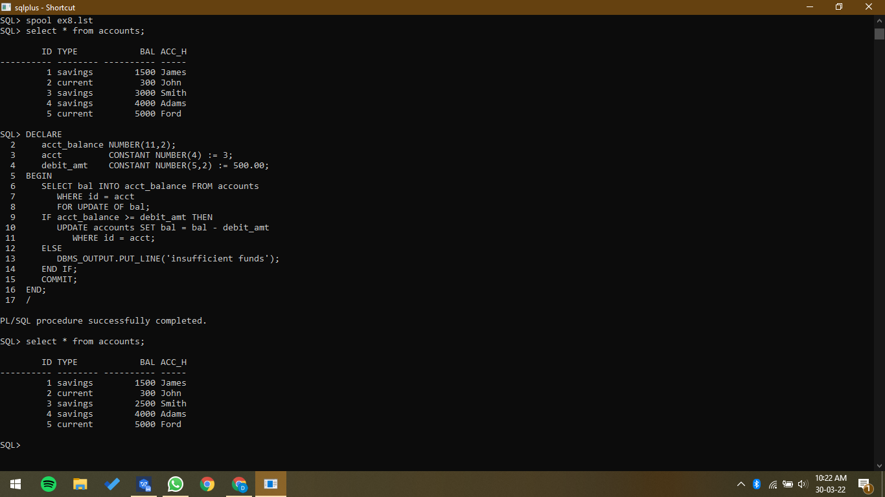

1. Write a PL/SQL program for finding the area of square, circle, and rectangle using switch case.

SQL> DECLARE

2 L NUMBER(4,2) := 3;

3 B NUMBER(4,2) := 7;

4 R NUMBER(1) := 5;

5 squarearea NUMBER(4,2);

6 rectarea NUMBER(4,2);

7 circlearea NUMBER(6,2);

8 pi CONSTANT NUMBER(3,2) := 3.14;

9 BEGIN

10 squarearea := L * L;

11 rectarea := L * B;

12 circlearea := pi * R * R;

13 dbms_output.Put_line('Area of square is ' || squarearea);

14 dbms_output.Put_line('Area of rectangle is ' || rectarea);

15 dbms_output.Put_line('Area of circle is ' || circlearea);

16 END;

17 /

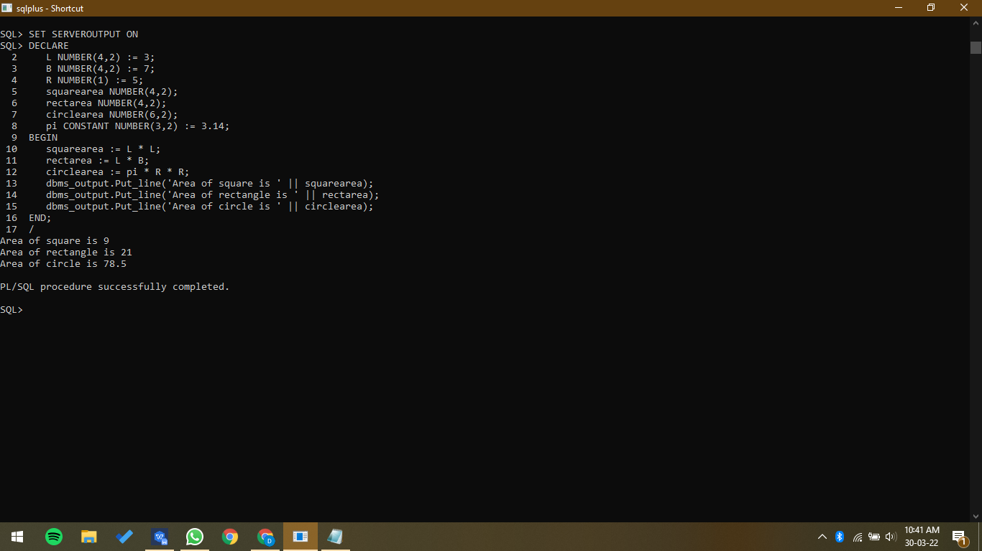

1. Write a PL/SQL program for finding the square roots of 1 to 25 using for loop.

SQL> DECLARE

2 i int;

3 BEGIN

4 i := 1;

5 LOOP

6 if i>25 then

7 exit;

8 end if;

9 dbms_output.put_line(SQRT(i));

10 i := i+1;

11 END LOOP;

12 END;

13 /

